11.1.1

Problem Statement
Write a Python program that reads an integer, calculates the sum of its digits, and prints the result.

Algorithm
- Start
- Read number num
- If num == 0 → return 0
- Else → return last digit + sum of remaining digits
- Call function
- Print result 7.Stop

Flowchart
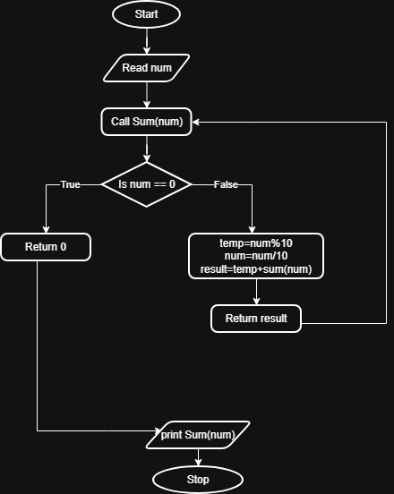
EXECUTION:
